Stumbling upon a new species of giant, woolly rat
By Devin Reese

April 22, 2016

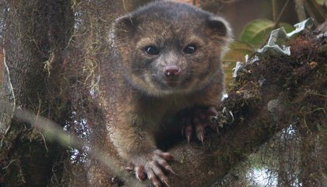
How would you feel if you encountered a rat almost three feet long?
Smithsonian's Dr. Kristofer Helgen was overjoyed. The rat was discovered by Kris and other members of a BBC expedition team. The rat was in a remote volcano in Papua New Guinea. They named it the Bosavi woolly rat, after its thick fur and its home on Mount Bosavi.
The Bosavi woolly rat has yet to receive its scientific name. Scientific naming reflects how an organism is classified in the tree of life. Biologists are still sorting it out for this rat. They do know that it belongs in the same family, the Muridae, as our common city black rats and Norway rats. They also know that it belongs in the genus Mallomys. It is a group that includes other oversized rats. But, its unique identifier - the species name - has yet to be announced.
What makes something a species? This can be a surprisingly hard question to answer. Many scientists think of a species as a group of living organisms that can reproduce and pass genes on to the next generation. Historically, scientists identified species by the way animals looked (their morphology) and behaved, sorting them into categories based on things like arrangement of teeth and diet. Species were sometimes misclassified if they looked similar, but were actually from different evolutionary lines.
Modern classification of species goes deeper to include other types of evidence, such as genetics. Genetics reveal evolutionary relationships. Scientists analyze DNA to determine how closely related an organism is to other, similar organisms, and where it fits into the evolutionary tree. Finding and classifying new species gets us closer to understanding the invaluable biodiversity of Earth.
Even for mammals, there is more biodiversity to discover. Kris Helgen has discovered about 100 new species. He is always on the lookout for more.

Name_____________________________________________ Period________________________
Questions:
- How do scientists figure out what species an organism is?
- By analyzing it’s DNA
- By looking at it
- By dissecting it
- All of the above

- What does a scientific name tell us about an organism?
- It tells us where it came from originally.
- It tells us the size and shape of the animal.
- It tells us the location where it was found.
- It tells us how an organism is classified.

- Which is not named as a member of the Muridae rat family in this article?
- Norway rats.
- Bosavi woolly rats.
- Black rats.
- Bulldog rat.

- What makes something a species?

- What does the article say about how modern classification works?

- What types of evidence is used to classify organisms?

- Why was Dr. Kristofer Helgen happy to see a giant rat?

