Name_____________________________________________ Period________________________
Questions:

- What is a noted ability of an Arctic butterfly?
- They appear to have frosted wings to fool predators.
- They are able to live in colder areas than a regular butterfly.
- They can regulate body temperatures to match the cold air outside.
- They choose to migrate to Alaska during the winter months.

- How is the Tanana Artic butterfly different from the Chryxus butterfly?
- It has a smaller wingspan.
- It is larger in size.
- It weighs more.
- It has darker color.

- What do scientists hope to find out about the Tanana Arctic butterfly?
- If it exists further east into the Yukon.
- It it is the same species as the Chruxus Arctic butterfly.
- If it exists further east into Russia.
- If it existed before it was first spotted 60 years ago.

- Why might the Tanana Arctic have a “frosted” appearance?
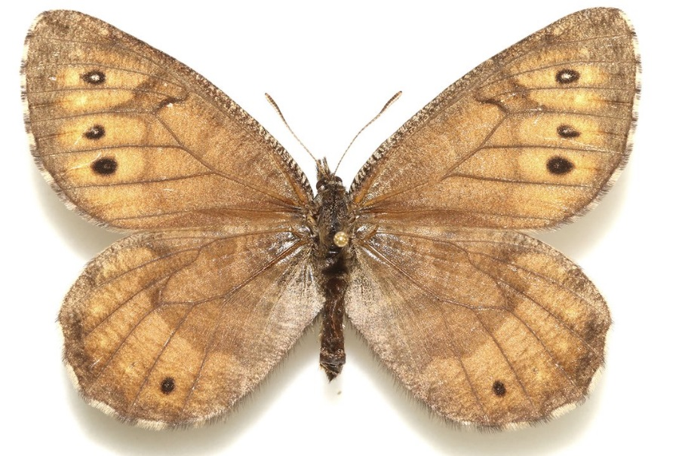

This image provided by lepidopterist Andrew Warren shows the newly discovered Tanana Arctic butterfly. (Andrew Warren/Florida Museum of Natural History via AP)

Alaska has a new butterfly
By Associated Press

March 25, 2016
A new species of butterfly could provide clues about Alaska's geological history and its changing climate. This is according to a University of Florida researcher.
Research by lepidopterist Andrew Warren suggests that the newly discovered Tanana Arctic butterfly evolved from the offspring of two related butterfly species. They are the Chryxus Arctic and the White-veined Arctic. He thinks all three species lived in the Beringia region before the last ice age. The story was reported in The Daily News-Miner. The newspaper is in Fairbanks, Alaska.
Scientists have been seeing the Tanana Arctic butterfly for more than 60 years. Its similarity to the Chryxus Arctic led them to believe it was the same species. Warren noticed its distinct characteristics. He is senior collections manager at the McGuire Center for Lepidoptera and Biodiversity at the Florida Museum of Natural History. It is on the UF campus in Gainesville.
The Tanana Arctic has white specks on the underside of its penny-colored wings. They give it a "frosted" appearance. It is larger and darker than the other species.
It also has a unique DNA sequence. It is very similar to that in nearby populations of White-veined Arctics, said Warren. This has led to the hypothesis that the new species is a hybrid.
More field research is needed. Scientists want to find out whether the Tanana Arctic also exists further east into the Yukon. Arctic butterflies live in environments that are too cold and extreme for most other butterflies. They can survive in part thanks to natural antifreeze their bodies produce.
"Once we sequence the genome, we'll be able to say whether any special traits helped the butterfly survive in harsh environments," said Warren.
He plans to return to Alaska and look for the butterfly next year. Warren wants to collect new specimens in order to fully sequence the genome. It could reveal the species' history and show whether it's truly a hybrid.
The Tanana Arctic lives in spruce and aspen forests in the Tanana-Yukon River Basin. Because butterflies react quickly to climate change, the new species could serve as an early warning indicator for the remote region.
"This butterfly has apparently lived in the Tanana River valley for so long that if it ever moves out, we'll be able to say 'Wow, there are some changes happening,'" Warren said. "This is a region where the permafrost is already melting and the climate is changing."

