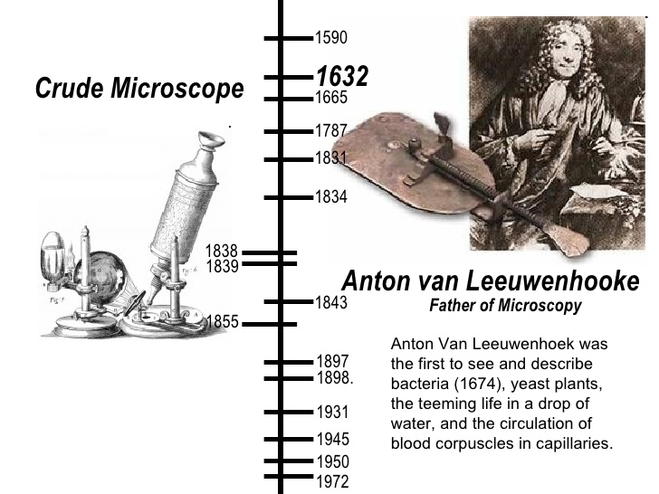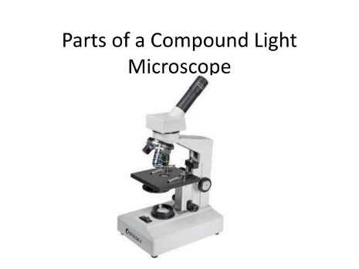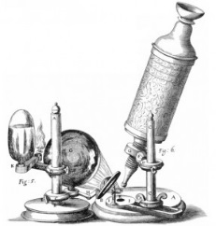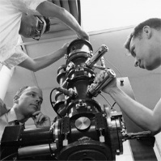

**Early 1700’s**

Robert Hooke saw cells under a microscope!

**1590**

Hans Janssen and his son made one of the first compound microscopes.

**1931**

Ruska and Knoll invent the electron microscope allowing us to magnify things up to 10,000x!

**1683**

Anton van Leeuwenhoek made a simple microscope that would magnify an object 266 times! He was the first to see many one celled organisms.

**1886**

The modern compound light microscope was invented

History of the Microscope