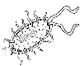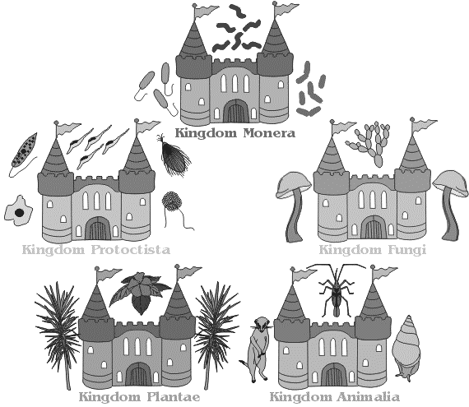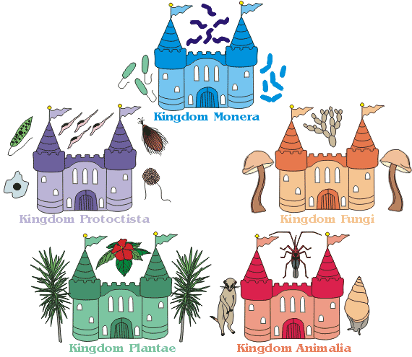



**Kingdom Fungi**

**Kingdom Bacteria**

Hot springs

Geysers

Salt Flats

**Kingdom Archaebacteria**

**Kingdom Plantae**

**Kingdom Protista**

**Kingdom Animalia**