Basic Measuring Tools

Type of tool | Units Measured | What it measures | How to measure
Graduated cylinder |  |  | 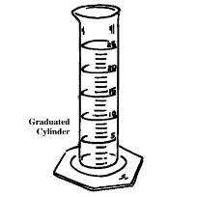
Triple beam balance |  |  | 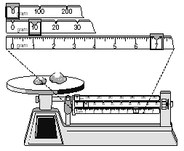
Meter Stick |  |  | 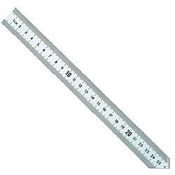

Type of tool | Units Measured | What it measures | How to measure
Graduated cylinder | Milliliters (mL) | Volume
Triple beam balance | Grams (g) | Mass
Meter Stick | Centimeters (cm) or meters (m) | Length

